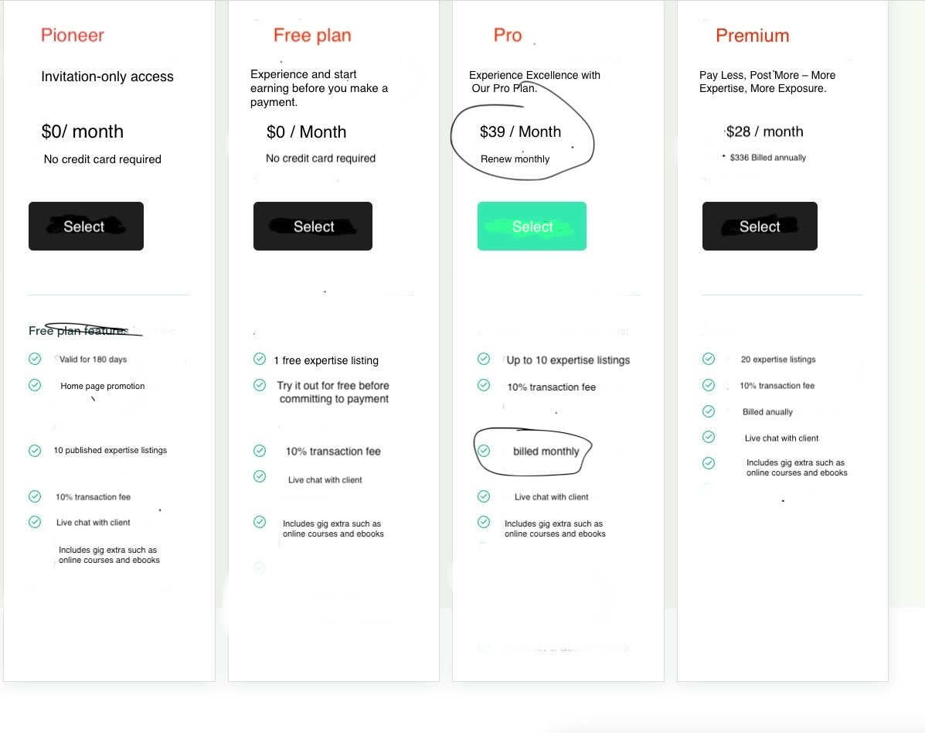

|  |  |  |  |
| --- | --- | --- | --- |
| Free Plan | Pioneer Plan | Pro Plan | Pro Plus Plan |
| 1 Post | 10 Posts | 10 Posts | 20 Posts |
| Duration : 30 days | Duration : 60 days | Duration : 120 days | Duration : 360 days |
| Monthly Renewal | Monthly Renewal | Monthly Renewal | Monthly Renewal |
| Transaction Fee : 30% | Transaction Fee : 20% | Transaction Fee : 10% | Transaction Fee : 5% |
| Price : 0$ | Price : 20$ | Price : 40$ | Price : 80$ |

**Definition :**

* Only the expertise can subscribe to these plans.
* Posts is used to submit post a service.
* Duration : the time when the post will exist , when the time expire , the mjob ( service ) will be automatically archived ( not public anymore ).
* Transaction fee : the commission which admin will get when the seller complete the job and admin can set this.
* Price : the cost of the plan ( admin can set this ).
* Renewal : the users should renew every month, if the users don’t spend all the posts , the left posts will be lost.
* The users can only subscribe one plan at the same time, when the users subscibe to new plan, the left posts of the old plan will be lost.

You agree to use our services in compliance with all applicable laws and regulations.

You shall not engage in any prohibited activities as outlined in our policies.

you agree to pay the fees as specified by Guide per hour. Payment terms, methods, and billing cycles are outlined in our pricing and payment policies.

The details about subscription terms, renewal processes, and cancellation policies are provided in our Subscription Agreement.